Process and safety solo task
In this file is all information about the process and safety solo task from Anjo Bouwmeester.
The task that needs doing:
Individually you will write a small PLC program of a self-chosen process (you may "translate" a personal routine into code) in Structured Text with supported documentation in GIT version control.
The self-chosen process is about a student who is studying. The student wants coffee after a while.

  - The PLC program must contain:
    - 2 tasks running independently
      - Student learning (PRG_Student)
      - Coffe machine working (PRG_Machine)
    - 1 function called by at least one task
      - Calculating coffee brew time (Calctime)

    - a Global Variable List from which the 2 tasks read and write variables
  - Your documentation must contain:
    - One State diagram for each task
    - One Sequence diagram depicting the communication between the tasks
    - One Sequence diagram showing the calling of the function by the task.

Plantuml
The diagrams are made in Plantuml. Here is a legend:

What | Description
@startuml / @enduml | Start/stop from the code from the picture
Title | The text that is on top
Hide empty description | No unnecessary empty boxes
[*] | Start point after reset
State name | Naam state for cases
-> | Gives direction for the diagram
[] | If statement
Autonumber | Counter for the diagram
Note | Notation

Diagrams
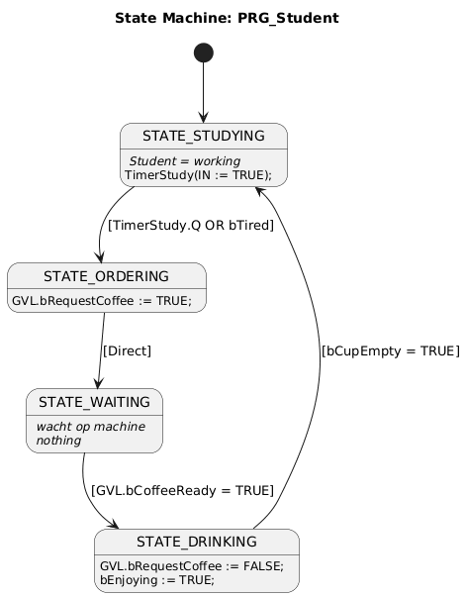
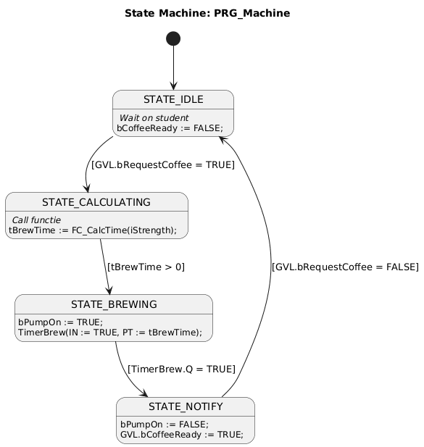
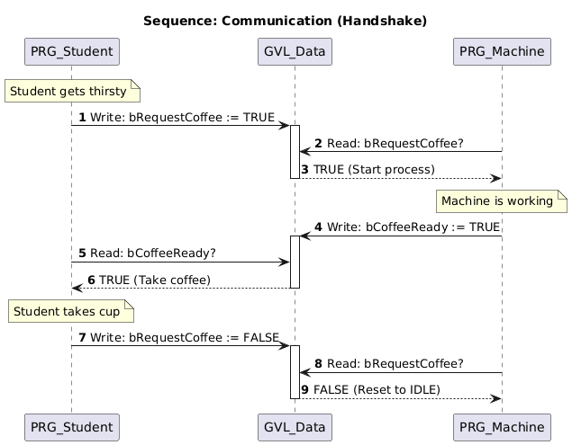
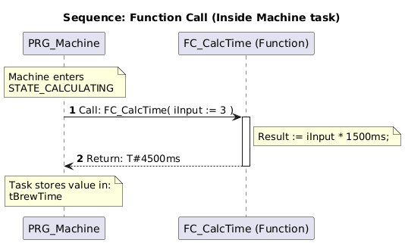
Below are the diagrams made with plantuml.

State student diagram code
@startuml
title State Machine: PRG_Student
hide empty description
[*] --> STATE_STUDYING
state STATE_STUDYING {
STATE_STUDYING : // Student = working //
STATE_STUDYING : TimerStudy(IN := TRUE);
}

' koffie = Time over OR Tired
STATE_STUDYING --> STATE_ORDERING : [TimerStudy.Q OR bTired]

state STATE_ORDERING {
' Action: Write to GVL
STATE_ORDERING : GVL.bRequestCoffee := TRUE;
}

STATE_ORDERING --> STATE_WAITING : [Direct]

state STATE_WAITING {
STATE_WAITING : // wacht op machine //
STATE_WAITING : // nothing //
}

'Wait until GVL variable becomes TRUE
STATE_WAITING --> STATE_DRINKING : [GVL.bCoffeeReady = TRUE]

state STATE_DRINKING {
' Als koffie -> reset request
STATE_DRINKING : GVL.bRequestCoffee := FALSE;
STATE_DRINKING : bEnjoying := TRUE;
}

STATE_DRINKING --> STATE_STUDYING : [bCupEmpty = TRUE]
@enduml

State Machine diagram code
@startuml
title State Machine: PRG_Machine
[*] --> STATE_IDLE

state STATE_IDLE {
STATE_IDLE : // Wait on student //
STATE_IDLE : bCoffeeReady := FALSE;
}

' wacht op variable
STATE_IDLE --> STATE_CALCULATING : [GVL.bRequestCoffee = TRUE]

state STATE_CALCULATING {
STATE_CALCULATING : // Call functie //
STATE_CALCULATING : tBrewTime := FC_CalcTime(iStrength);
}

STATE_CALCULATING --> STATE_BREWING : [tBrewTime > 0]

state STATE_BREWING {
STATE_BREWING : bPumpOn := TRUE;
STATE_BREWING : TimerBrew(IN := TRUE, PT := tBrewTime);
}

STATE_BREWING --> STATE_NOTIFY : [TimerBrew.Q = TRUE]

state STATE_NOTIFY {
STATE_NOTIFY : bPumpOn := FALSE;
' coffee is ready
STATE_NOTIFY : GVL.bCoffeeReady := TRUE;
}

' wacht op reset commando
STATE_NOTIFY --> STATE_IDLE : [GVL.bRequestCoffee = FALSE]
@enduml

Sequence diagram communication code
@startuml
title Sequence: Communication
autonumber

participant "PRG_Student" as Student
participant "GVL_Data" as GVL
participant "PRG_Machine" as Machine

Note over Student: Student gets thirsty
Student -> GVL : Write: bRequestCoffee := TRUE
activate GVL

Machine -> GVL : Read: bRequestCoffee?
GVL --> Machine : TRUE (Start process)
deactivate GVL
Note over Machine: Machine is working
Machine -> GVL : Write: bCoffeeReady := TRUE
activate GVL

Student -> GVL : Read: bCoffeeReady?
GVL --> Student : TRUE (Take coffee)
deactivate GVL

Note over Student: Student takes cup

Student -> GVL : Write: bRequestCoffee := FALSE
activate GVL
Machine -> GVL : Read: bRequestCoffee?
GVL --> Machine : FALSE (Reset to IDLE)
deactivate GVL

@enduml

Sequence diagram function call (in machine task) code
@startuml
title Sequence: Function Call (Inside Machine task)
autonumber

participant "PRG_Machine" as Task
participant "FC_CalcTime (Function)" as Func

Note over Task: Machine enters\nSTATE_CALCULATING

' Eerste
Task -> Func : Call: FC_CalcTime( iInput := 3 )
activate Func

' Result blokje
Note right of Func
Result := iInput * 1500ms;
End note

' terug
Func --> Task : Return: T#4500ms
deactivate Func

Note over Task: Task stores value in:\ntBrewTime
@enduml

